Session 20 - APIs Using Requests (Part 1): Task Report

Task 1: GET Request for Posts
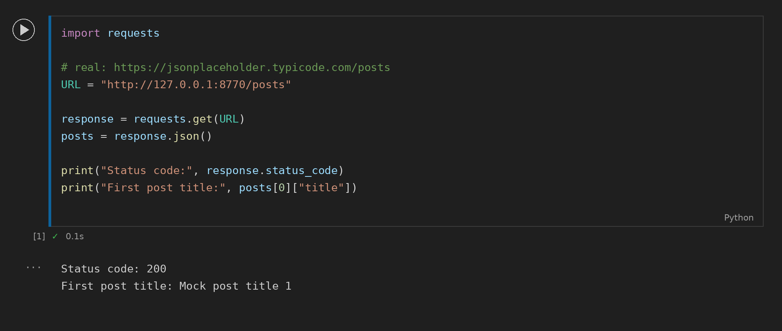

Task 2: POST Request
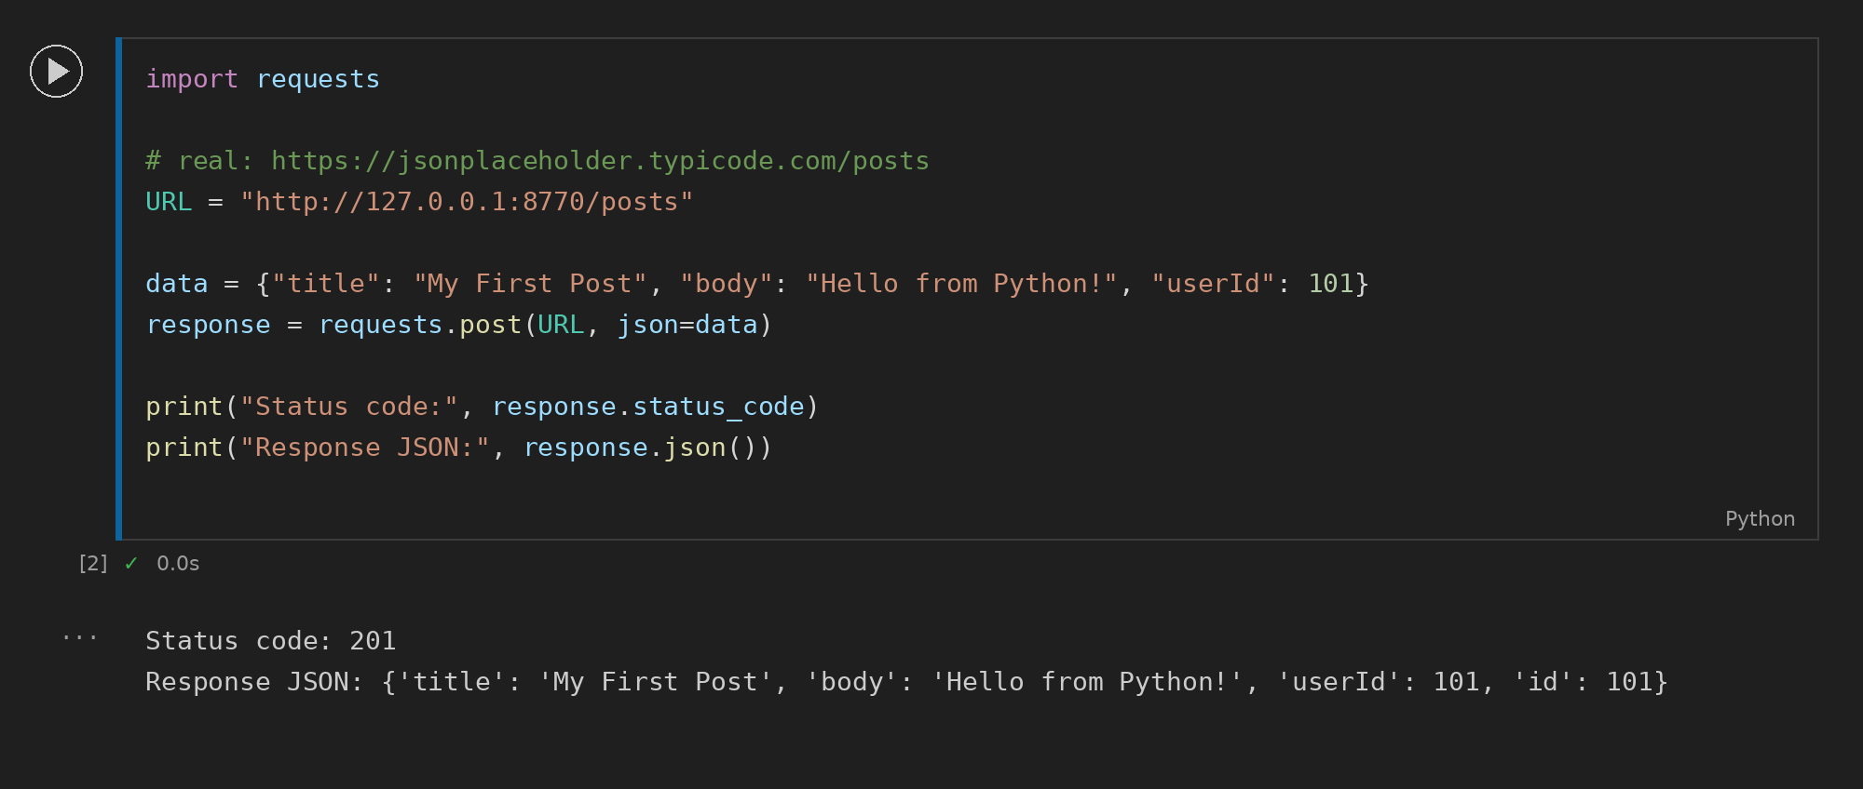

Task 3: Users with .org Email
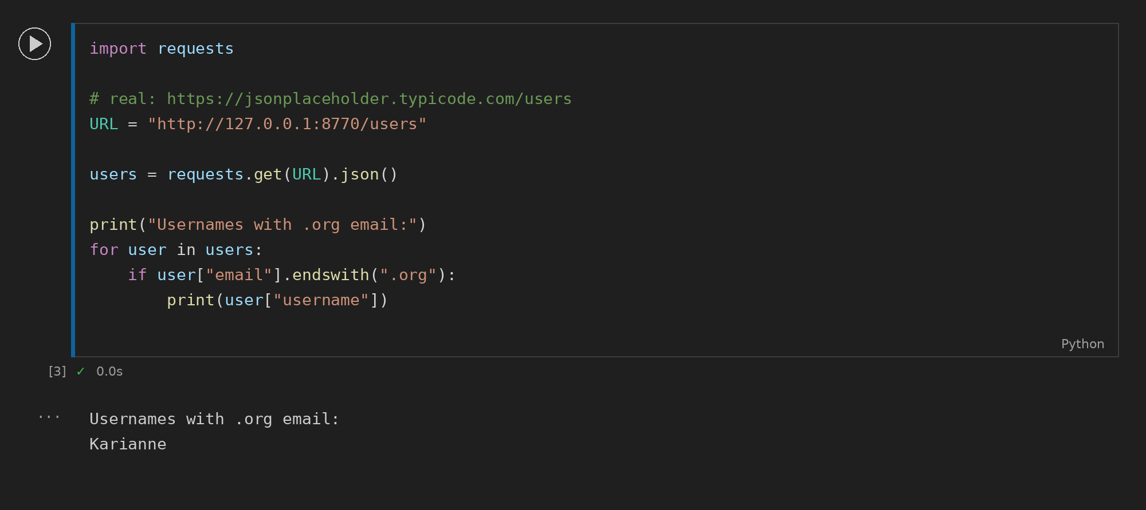

Task 4: OMDB Movie Search
